

|  |  |
| --- | --- |
|  | **imotion** |
|  |  |
|  | AbuDhabi MergeTool |
|  |  |
|  | User Manual |
|  |  |
|  | Technical Description |
|  |  |
|  | Version: 1.0 |
|  | State: Released |
|  | Classification: Internal use only |
|  | Author: RAN |
|  | Creation date: 2012-09-07 |
|  | Repository: $/Gorba/Main/Motion/Protran/Documents/TD_ProtranInstallation/ TD_AbuDhabi MergeTool .docx |
|  | Gorba AG  Sandackerstrasse  9245 Oberbüren  Switzerland |

**Table of contents**

1 Introduction 4

1.1 Scope 4

1.2 Intended Audience 4

2 Product Overview 4

2.1 Merge Tool Overview 4

2.2 Components 4

3 Procedure 4

3.1 Start Merge Tool 4

3.2 CU5 Files 5

3.2.1 Cu Select File 6

3.2.2 Merge Selected Cu Files 8

3.2.3 Cu files Merge Completion 9

3.2.4 Clear Status and Files 10

3.3 Topbox Files 10

3.3.1 Select Topbox folders 11

3.3.1.1 Select individual folders 12

3.3.1.2 Select top folder 14

3.3.2 Select/Deselect files in folders 16

3.3.3 Select Merge file type 16

3.3.4 Merge Selected Topbox Folders 17

3.3.5 Topbox files Merge Completion 18

3.3.6 Clear Status and Folders 19

4 Configuration 19

4.1 <Merge> 20

4.2 <Extensions> 20

4.3 <TopboxSoftware> 20

4.4 <TopboxData> 21

4.5 <CuSoftware> 21

4.6 <CuData> 21

5 Installation 21

5.1 Full installation 21

**Modification management**

|  |  |  |  |  |  |
| --- | --- | --- | --- | --- | --- |
| **Version** | **Date** | **Name** | **Dept.** | **Modifications** | **State** |
| 0.1 | 2012-09-11 | RAN | SW | Initial version | draft |
| 0.2 | 2012-09-19 | COS | SW | Checked the required components.  Checked the description of each XML tag. | draft |

**Review**

|  |  |  |  |  |
| --- | --- | --- | --- | --- |
| **Version** | **Date** | **Name** | **Dept.** | **Remarks** |
| 0.2 | 2012-09-19 | COS | SW | First review. |
|  |  |  |  |  |
|  |  |  |  |  |
|  |  |  |  |  |

**Release**

|  |  |  |  |  |
| --- | --- | --- | --- | --- |
| **Version** | **Date** | **Name** | **Dept.** | **Remarks** |
| 1.0 | 2012-09-19 | COS | SW | ok |
|  |  |  |  |  |
|  |  |  |  |  |
|  |  |  |  |  |

# Introduction

## Scope

This document is a user manual of AbuDhabi Merge Tool. The following sections give an overview of the Merge tool and a step-by-step procedure to use it.

## Intended Audience

This document is written to be understood by Gorba staff familiar with Gorba products. Minimal technical skills are required.

# Product Overview

## Merge Tool Overview

The Merge Tool is an application used to create the files required for software and data update of the following two systems.

* Topbox
* Cu

The software and data files are created with the correct extensions as described in the document 2.2.14.10_Interface_Infotainment_System_GORBA_2.5.pdf.

## Components

To use the AbuDhabi Merge Tool, the following files are required to be present.

* AbuDhabiMerge.exe
* AbuDhabiMerge.exe.config
* AbuDhabiMerge.xml
* Gorba.Common.Configuration.dll
* ICSharpCode.SharpZipLib.dll
* NLog.config
* NLog.dll

# Procedure

## Start Merge Tool

Click on “AbuDhabiMerge.exe” to start the Merge tool. The window as shown in Figure ‎3‑1 Main window of Merge Tool opens.

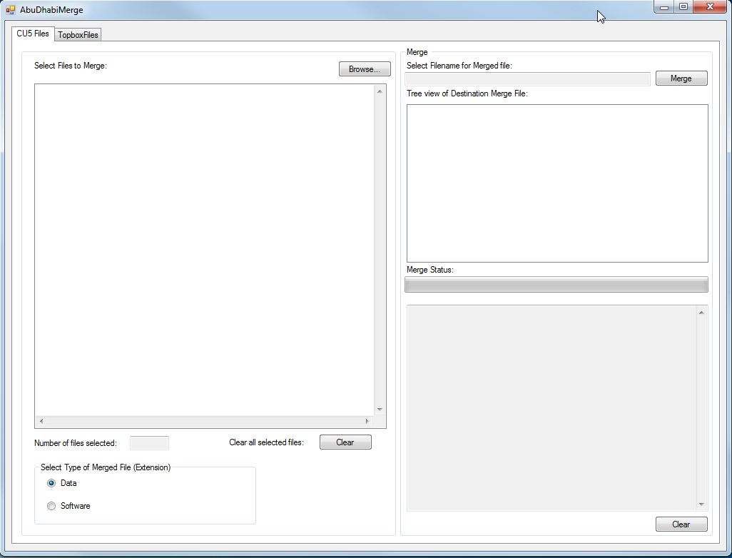

Figure ‎3‑1 Main window of Merge Tool

The Merge Tool has two tabs, one each for the Cu files and the Topbox files. The description of each of the tabs and its features are given in the next sections.

## CU5 Files

In the CU5 Files tab, click on the Browse button, to open a dialog to select the file for merge as shown in Figure ‎3‑2 Cu Browse Files.

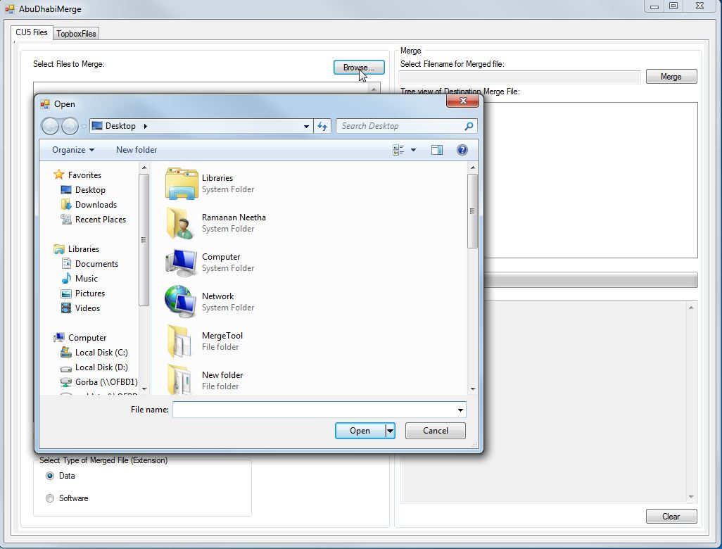

Figure ‎3‑2 Cu Browse Files

### Cu Select File

Navigate to the location of the files and select the required file or files to merge as shown in Figure ‎3‑3 Cu Select File.

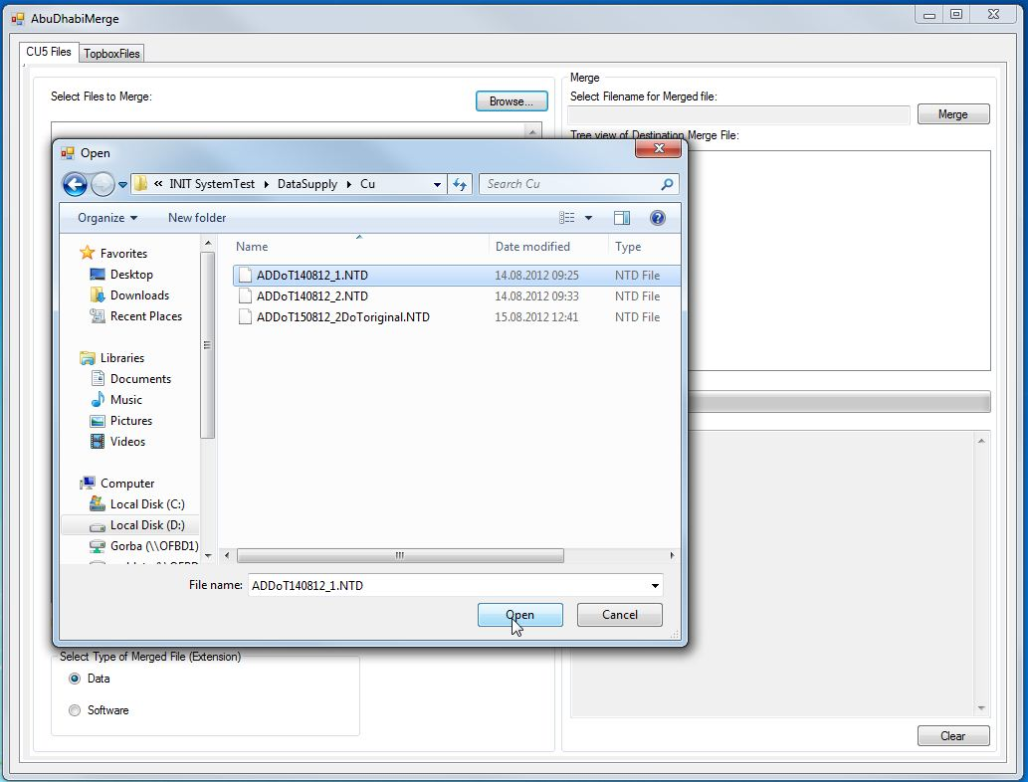

Figure ‑ Cu Select File

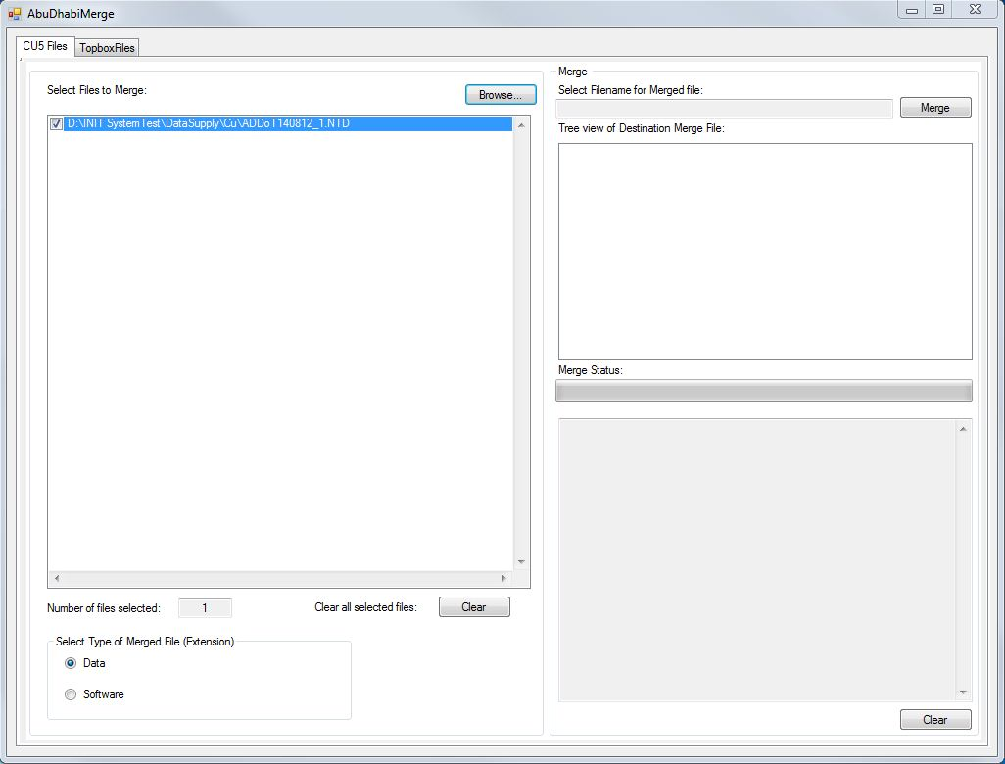

Figure ‎3‑4 Cu Merge Type Data

As seen in Figure ‎3‑4 Cu Merge Type Data, the ”Number of files selected” field shows the total number of files selected for merge. The type of the merged file can be selected by clicking on the correct radio button. The two options are Data and Software. The extension for the final merged file is given automatically based on the type selected here.

### Merge Selected Cu Files

To merge the selected files, click on the “Merge” button. This opens a dialog to select the filename for the merged file and the location to store the file as shown in Figure ‎3‑5 Merge Button Clicked.

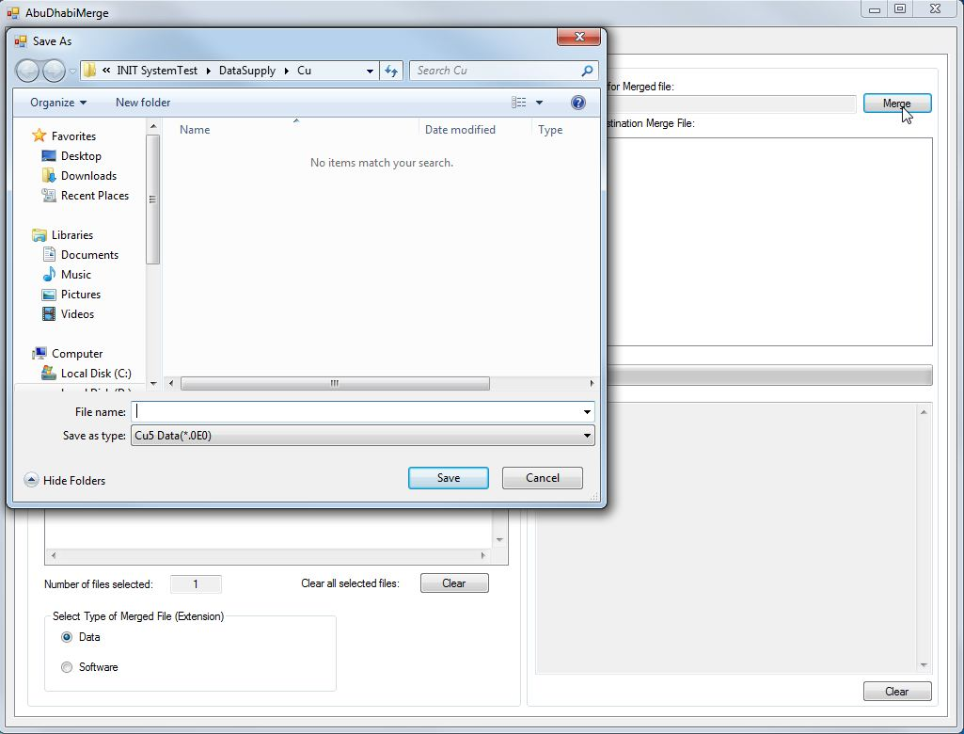

Figure ‎3‑5 Merge Button Clicked

The type of the file saved is fixed based on the Data and Software type selected earlier. Type the filename for the merged file in “File name” section. Navigate and select the location to save the merged file and then click on “Save” button in the dialog.

### Cu files Merge Completion

Once the “Merge” button is clicked, the process to merge the selected files with the pre-selected extension begins.

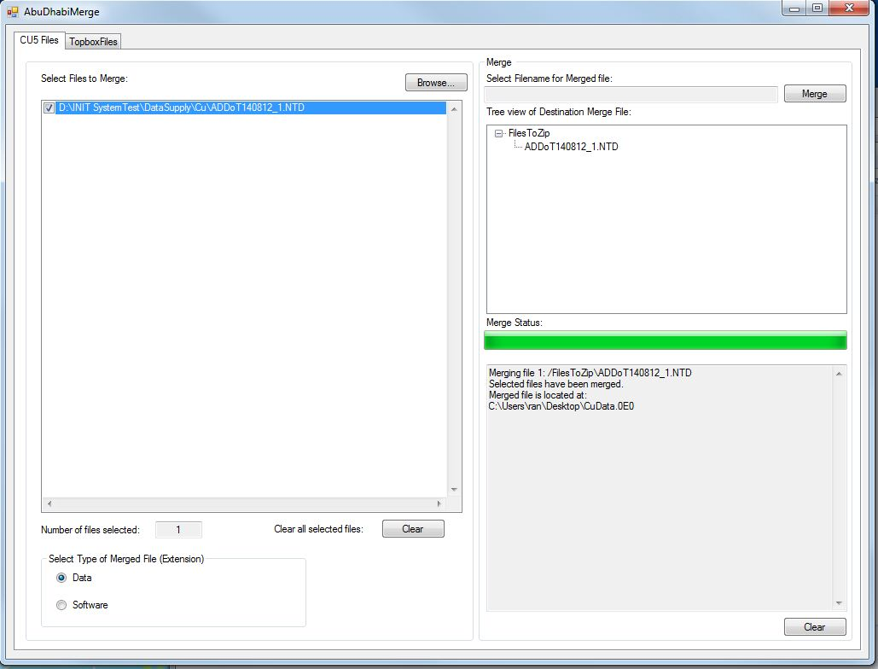

Figure ‎3‑6 Cu Files Merge Completion

A progress bar indicates the merge state and the files being merged are listed below. The “Tree view of Destination Merge File” presents the full view of the files selected for merge. Upon completion, the status of the merge process is as shown in Figure ‎3‑6 Cu Files Merge Completion.

### Clear Status and Files

To clear the merge status, click on the “Clear” button below it. To clear all the selected files for merge, click on the “Clear” button next to “Clear all selected files”.

## Topbox Files

The Topbox Files tab is shown in Figure ‎3‑7 Topbox Files Tab.

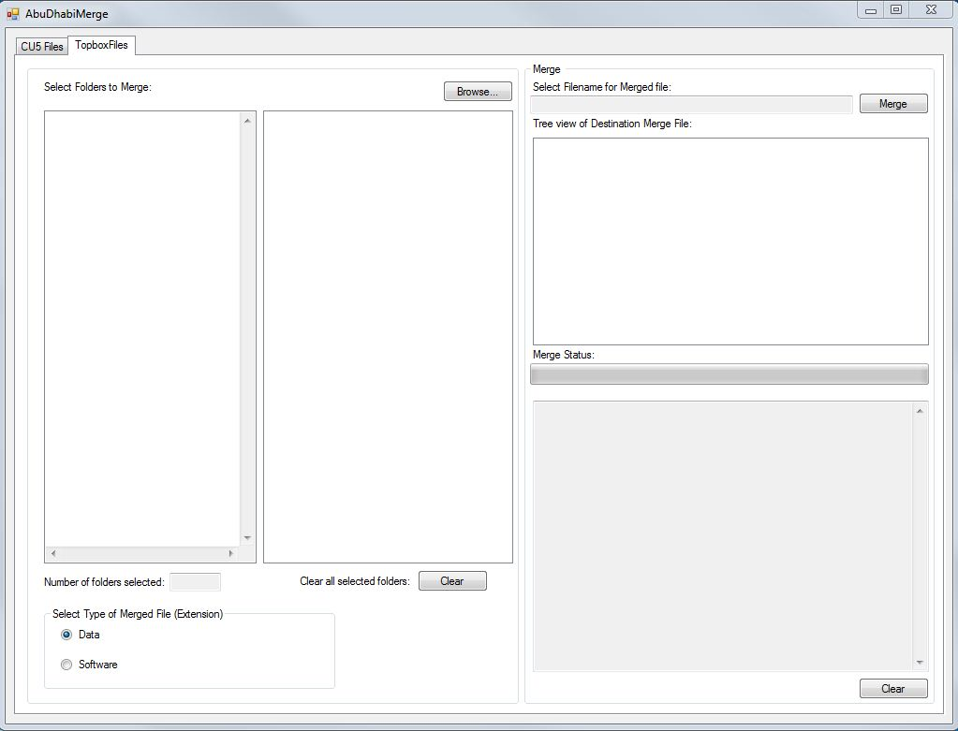

Figure ‎3‑7 Topbox Files Tab

### Select Topbox folders

In the Topbox Files tab, click on the Browse button, to open a dialog to select the folders for merge as shown in Figure ‎3‑8 Topbox folders Browse.

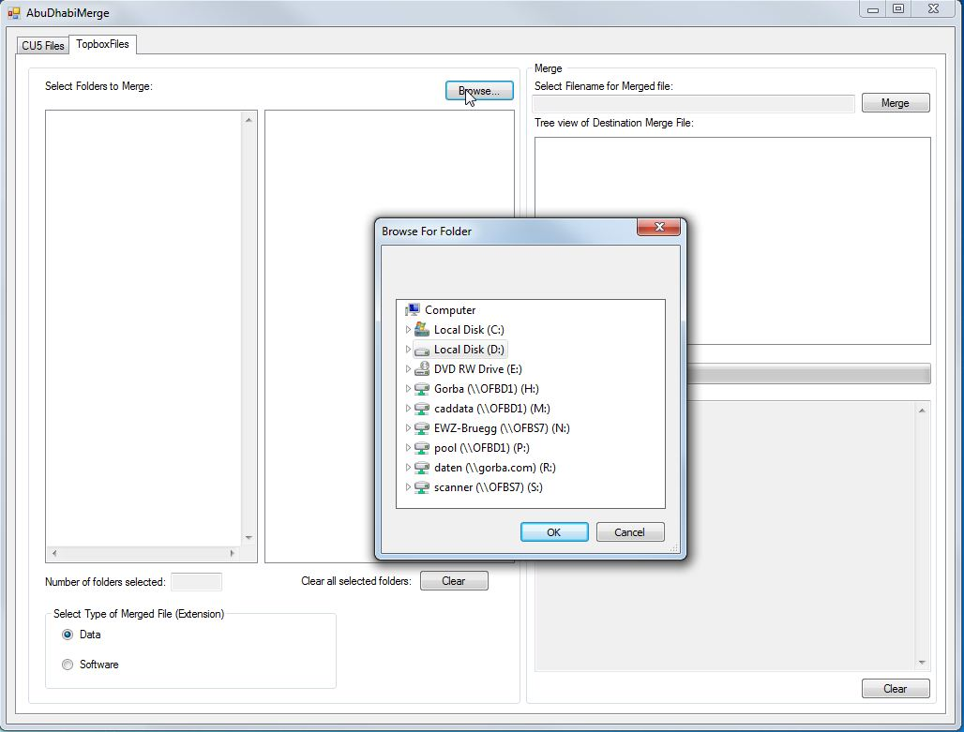

Figure ‎3‑8 Topbox folders Browse

There are two possible ways to select the required folders for merge.

#### Select individual folders

To select individual folders, just click on the folders required to be merged one at a time as shown in Figure ‎3‑9 Select Individual folders.

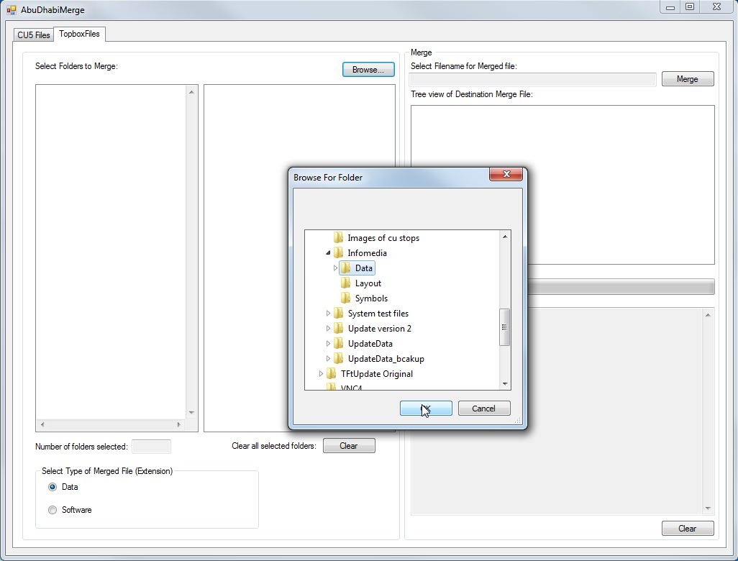

Figure ‎3‑9 Select Individual folders

Upon selecting, click “OK” to select the folder. The internal structure of the selected folder with all its contents is shown in a tree view as shown in Figure ‎3‑10 Tree view of folder structure at source.

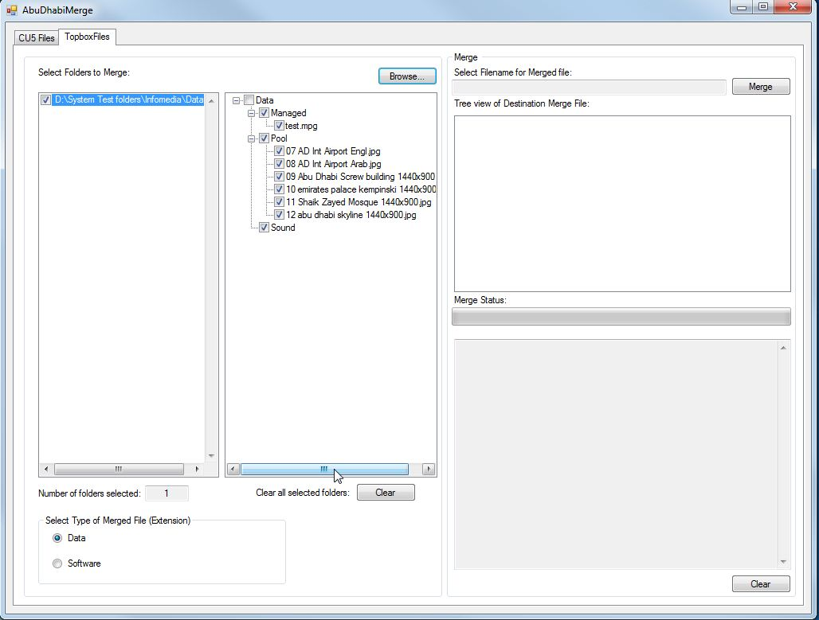

Figure ‎3‑10 Tree view of folder structure at source

#### Select top folder

To select the top folder, just click on the top folder required to be merged as shown in Figure ‎3‑11 Select Top folder.

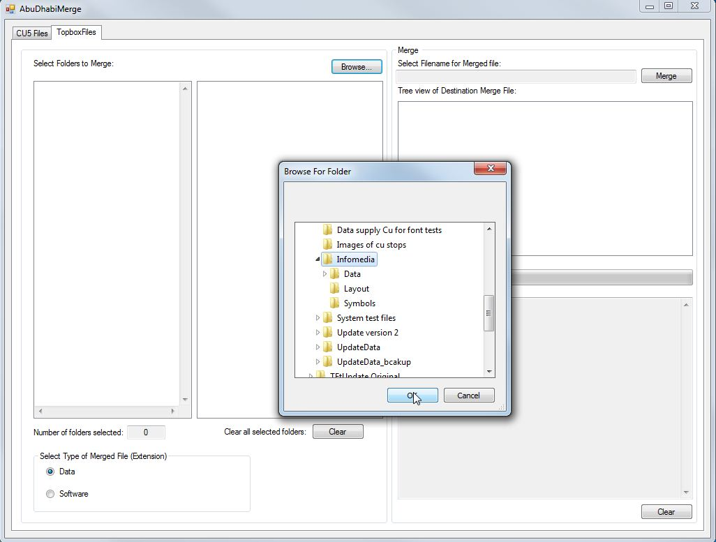

Figure ‎3‑11 Select Top folder

Upon selecting, click “OK” to select the folder. The internal structure of the selected folder with all its contents is shown in a tree view as shown in Figure ‎3‑12 Tree view of top folder structure at source.

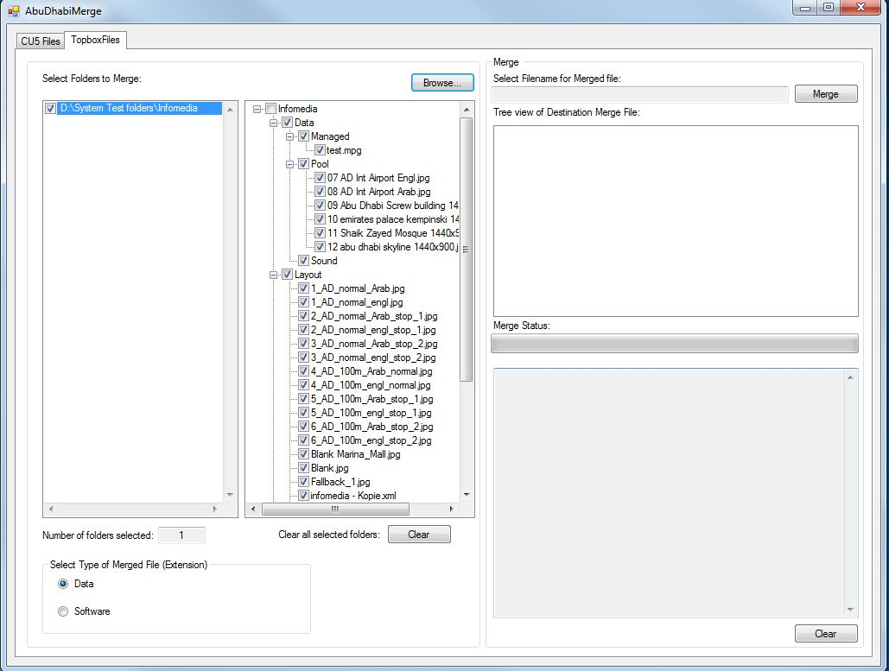

Figure ‎3‑12 Tree view of top folder structure at source

### Select/Deselect files in folders

It is possible to select or deselect individual files from the folders in the tree view at source. Click on the checkbox associated with the particular file to select or deselect the files. The deselected files shall not be included in the final merged file.

### Select Merge file type

The type of the merged file can be selected by clicking on the correct radio button. The two options are Data and Software as shown in Figure ‎3‑13 Merge file type selection. The extension for the final merged file is given automatically based on the type selected here.



Figure ‑ Merge file type selection

### Merge Selected Topbox Folders

To merge the selected files, click on the “Merge” button. This opens a dialog to select the filename for the merged file and the location to store the file as shown in Figure ‎3‑14 Merge Button Clicked.

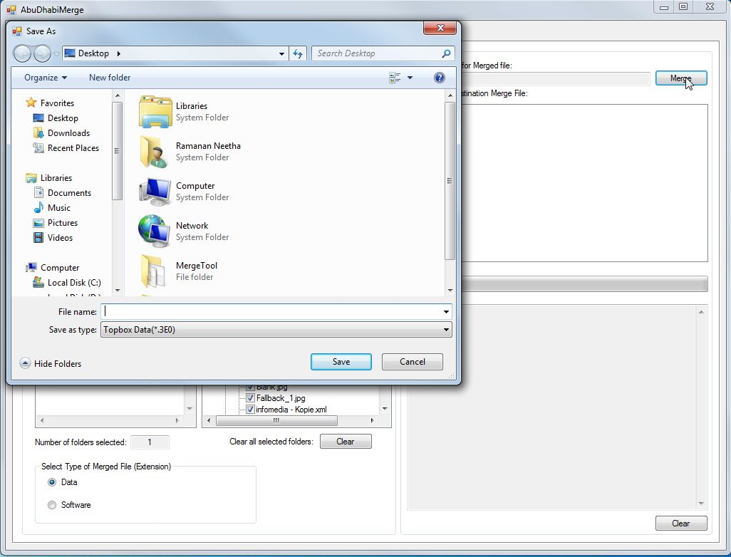

Figure ‎3‑14 Merge Button Clicked

The type of the file saved is fixed based on the Data and Software type selected earlier. Type the filename for the merged file in “File name” section. Navigate and select the location to save the merged file and then click on “Save” button in the dialog.

### Topbox files Merge Completion

Once the “Merge” button is clicked, the process to merge the selected files with the pre-selected extension begins.

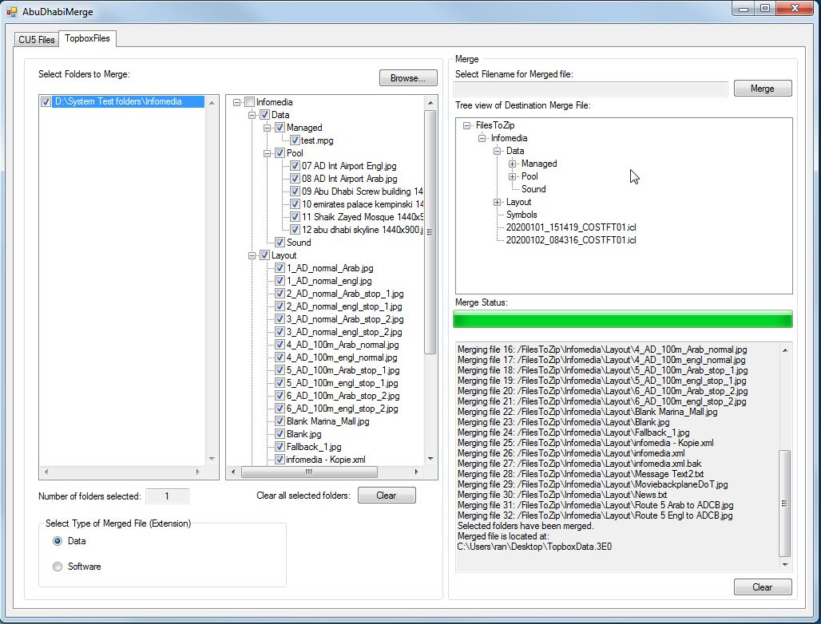

Figure ‎3‑15 Topbox Folders Merge Completion

A progress bar indicates the merge state and the files being merged are listed below. The “Tree view of Destination Merge File” presents the full view of the folders and files selected for merge. Upon completion, the status of the merge process is as shown in Figure ‎3‑15 Topbox Folders Merge Completion.

### Clear Status and Folders

To clear the merge status, click on the “Clear” button below it. To clear all the selected folders for merge, click on the “Clear” button next to “Clear all selected folders”.

# Configuration

The file “AbuDhabiMerge.xml” has to be stored in the same directory as AbuDhabiMerge.exe for correct operation.

The AbuDhabiMerge.xml is the configuration file for the AbuDhabiMerge. It consists of the configuration of the different extensions possible for merged files. Below is an example of the AbuDhabiMerge.xml file as shown in Figure ‎4‑1 AbuDhabiMerge.xml example.

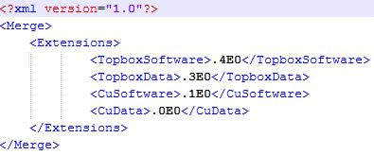

Figure ‎4‑1 AbuDhabiMerge.xml example

Below is the description of the tags specified in the configuration file:

## <Merge>

This is the root of the document.

|  |  |  |  |
| --- | --- | --- | --- |
| **Tag’s attributes** | **Mandatory** | **Tag’s Meaning** | **Values admitted (default value)** |
| No | Yes | Just the container of all the other tags. | No value. Only its allowed sub-tags. |

Figure ‎4‑2 Merge tag

The sub-tags allowed are:

* <Extensions> (only one is accepted)

## <Extensions>

|  |  |  |  |
| --- | --- | --- | --- |
| **Tag’s attributes** | **Mandatory** | **Tag’s Meaning** | **Values admitted (default value)** |
| No | Yes | Just the container of all the other sub-tags. | No value. Only its allowed sub-tags. |

Figure ‎4‑3 Extensions sub-tag

The sub-tags allowed are:

* <TopboxSoftware> (only one is accepted)
* <TopboxData> (only one is accepted)
* <CuSoftware> (only one is accepted)
* <CuData> (only one is accepted)

## <TopboxSoftware>

|  |  |  |  |
| --- | --- | --- | --- |
| **Tag’s attributes** | **Mandatory** | **Tag’s Meaning** | **Values admitted (default value)** |
| No | No | Contains the extension for merge file for the topbox software | A string. |

Figure ‑ TopboxSoftware sub-tag

## <TopboxData>

|  |  |  |  |
| --- | --- | --- | --- |
| **Tag’s attributes** | **Mandatory** | **Tag’s Meaning** | **Values admitted (default value)** |
| No | No | Contains the extension for merge file for the topbox data | A string. |

Figure ‑ TopboxData sub-tag

## <CuSoftware>

|  |  |  |  |
| --- | --- | --- | --- |
| **Tag’s attributes** | **Mandatory** | **Tag’s Meaning** | **Values admitted (default value)** |
| No | No | Contains the extension for merge file for the Cu software | A string. |

Figure ‑ CuSoftware sub-tag

## <CuData>

|  |  |  |  |
| --- | --- | --- | --- |
| **Tag’s attributes** | **Mandatory** | **Tag’s Meaning** | **Values admitted (default value)** |
| No | No | Contains the extension for merge file for the Cu data | A string. |

Figure ‑ CuData sub-tag

# Installation

## Full installation

To install AbuDhabiMerge, you require the following files to be present in one location.

* AbuDhabiMerge.exe
* AbuDhabiMerge.exe.config
* AbuDhabiMerge.xml
* Gorba.Common.Configuration.dll
* ICSharpCode.SharpZipLib.dll
* NLog.config
* NLog.dll

Place all the above specified files in a folder. Double click on AbuDhabiMerge.exe to start the application.